**4. TO EVALUATE APPLICATION OF INTERACTIVE WEB GIS MAP IN CHOLERA OUTBREAK MANAGEMENT.**

Descriptive statistics based on measure of frequency was performed to evaluate the performance and satisfaction of interactive GIS map. System evaluation guided by three basic measurements; web structure, web content and web usage was conducted with representative from different stakeholders in Karonga district. Representatives from Karonga district Hospital, Organized Network of Services for Everyone’s Health (ONSE) organization, Karonga district disaster management office, Karonga district information office and University of Livingstonia were involved in evaluation of interactive GIS user interface.

**4.1. Web content dimension**

Figure 1 shows evaluation results based on web content quality. The results show that 57.1% of evaluators realized the excellence of the web GIS product based on its relevant indicator in decision making for disease management. The descriptive statistics indicated that 42.9% of evaluators mentioned that the product is relevance in health information sharing, disease hotspot tracking and support proper resources allocation.

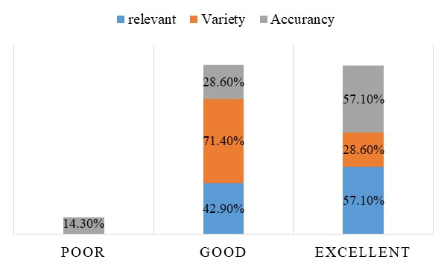

**Figure 1: Web content quality**

The evaluation results shows that 71.4% and 28.6% of evaluators mentioned that it is very good and excellent respectively for presenting interface in different forms of presentig the interactive GIS index. This gives an oppoturnity to the users to chose their best fit form of presentating the interface. Further more, the interactive GIS index can be hosted in the personal computer and in the free web server such GitHub. Figure 2 shows different forms of presenting interactive GIS

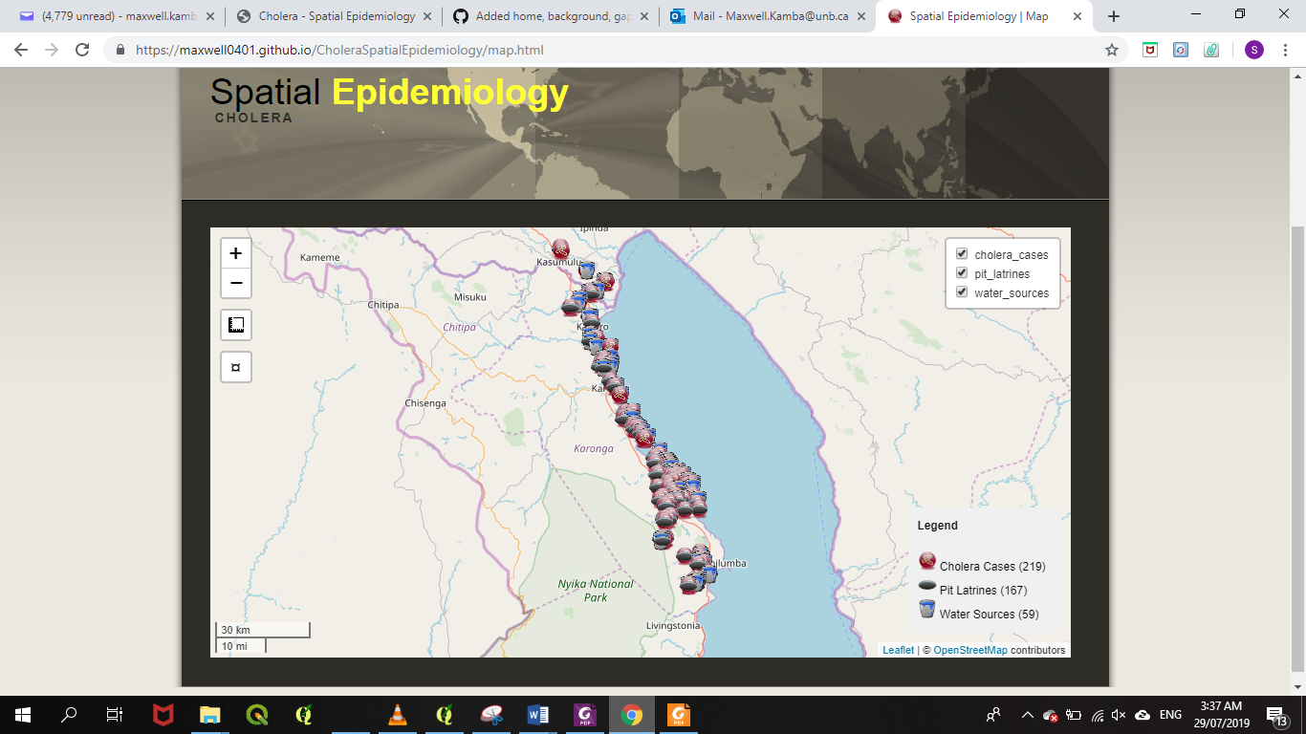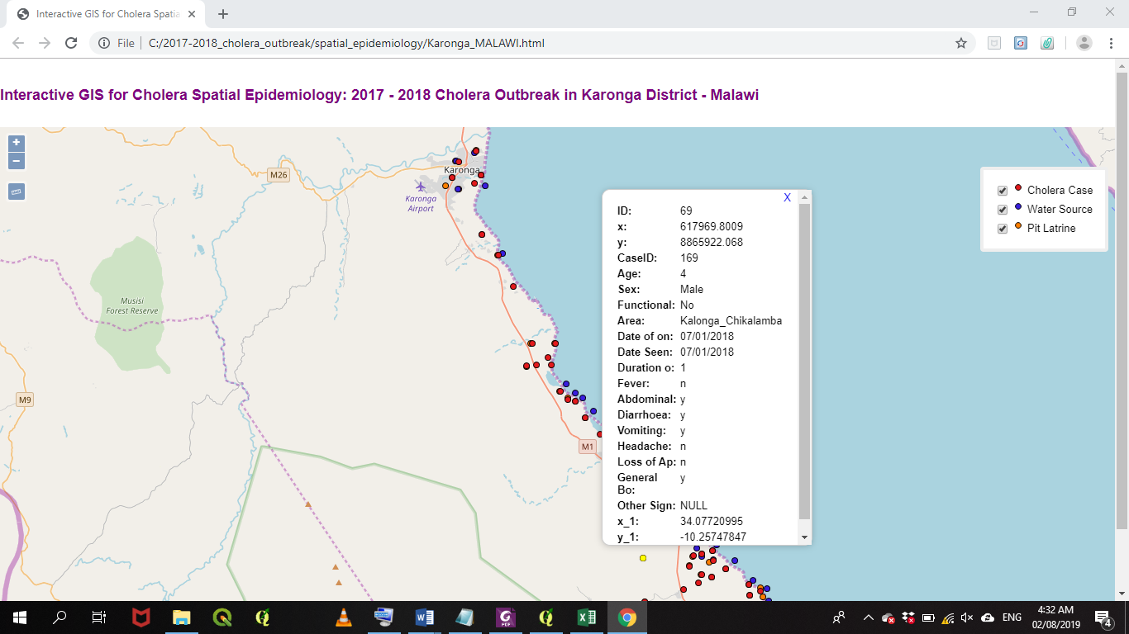

**a**

**b**

**Figure 2: Interactive GIS presentation (a) web hosting server (GitHub), (b) hosted in personal computer**

Interactive map shows its aaccuracy information with no spelling errors, precisse overlaying of vector layers with open source baase map, provide accurate measuring ressults for area and distance. Figure 1 shows that 57.1% of evaluators indicate excellent in accuracy of the information for the developed interactive GIS map.

**4.2. Design quality dimension**

The design quality for interactive GIS map was measured based on attractive, appropriate, text and color. The majority (85.7%) of evaluators mentioned that the interface is very attractive to the users with its attrictive widgets, innovative and aesthetic effects such as measuring tools, zoom options, interface layout and tabs for effective navigation. It was also indicated that the interface shows excellent appropriante in public health, health information sharing, decision making and with appropriate balancing of interface color and text. The analysis shows that 57.1% of evaluators found the interface text was consistency, readable, able in scrolling text and in relative size with good background and text color.

**Table 1: Design quality evaluation results**

|  |  |  |  |
| --- | --- | --- | --- |
| Indicator | Poor (%) | Good (%) | Excellent (%) |
| Attractive | 0 | 14.3 | 85.7 |
| Appropriate | 0 | 57.1 | 42.9 |
| Text | 0 | 42.9 | 57.1 |
| Color | 0 | 57.1 | 42.9 |

**4.3. Organization quality dimension**

Figure 3 shows the general layout of the interactive GIS interface. The majority (57.1%) of evaluators indicated that the map has good interactive features such as pop-ups on hover, measuring tools and collapsed map layers. About 57.1% of the evaluators indicated that the map shows good cartographic features such legend and scale with excellent consistency map layout. The interactive GIS index allows for a good speed downloads of spatial layers in KMZ file format which can be converted in different file formats.

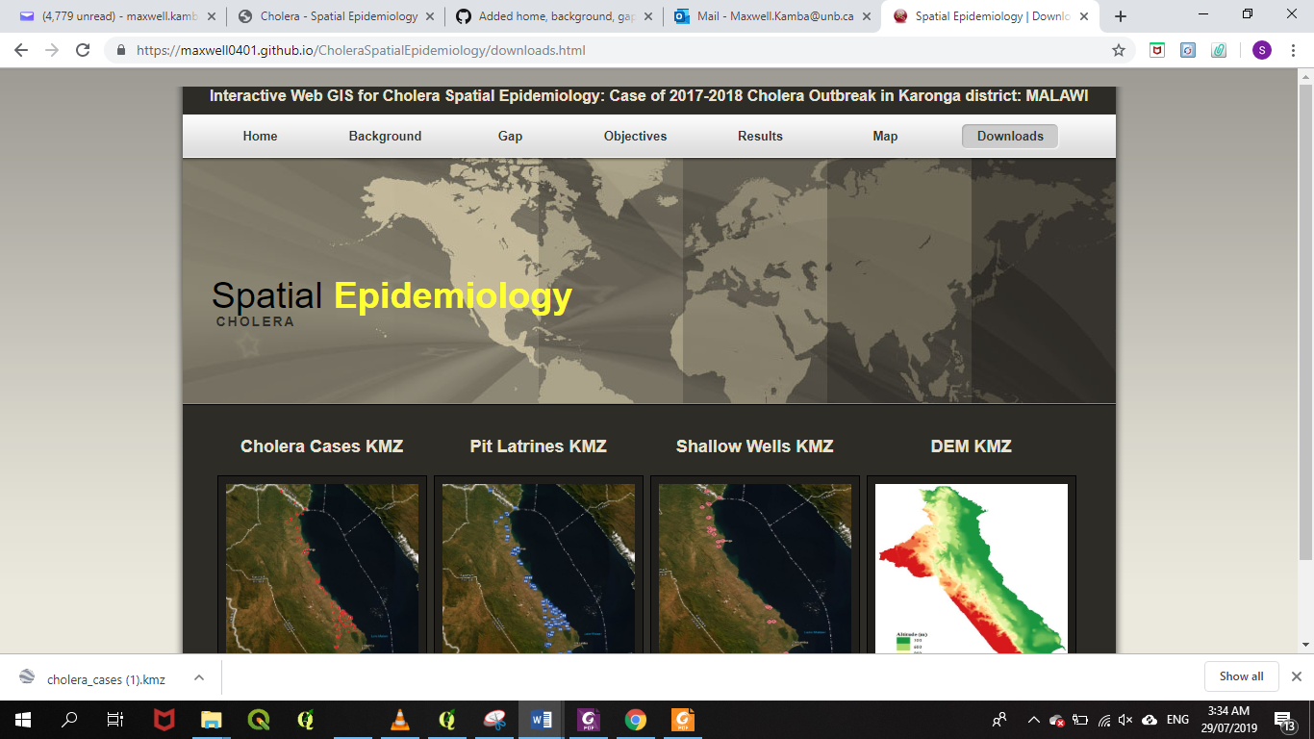

**Figure 3: General layout of the interactive GIS map**

**4.4. User-friendly quality dimension**

Usability quality evaluation of the interface shows that 57.1 % and 42.9% of the evaluators indicated that the interface has excellent and good usability quality respectively with easy to use, understand, find and navigate. Respectively, 57.1 % and 42.9% of the evaluators shows that the interface has good and excellent reliable features and functions with access to multiple browser and decision making efficiency.

Overall evaluation results show that 54.8%, 44.1% and 1.2% of the evaluators indicated that the interactive GIS interface has excellent, good and poor content, design, organization and user-friendly quality dimensions respectively.